# VISVESVARAYA TECHNOLOGICAL UNIVERSITY

## Jnana Sangama, Belgaum-590014

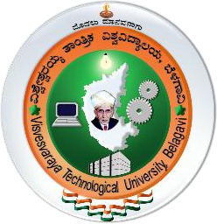

**“Data Science & it’s Application”**

**Mini Project Report**

**On**

**“WEB SCRAPPING ON FLIPKART.COM”**

**Submitted in Partial fulfillment of the Requirements for the VI Semester (2023-2024) for the Degree of**

## Bachelor of Engineering

**In**

## Artificial Intelligence & Machine Learning

**By,**

**Gagan D N(1CE21AI009)**

**Kailash Rao(1CE21AI010)**

**Under the Guidance of Mrs. Nasrath B K**

**Asst. Professor, Dept. of AI&ML**



# CITY ENGINEERING COLLEGE

**Doddakallasandra, Kanakapura Road,Bengaluru-560061**

# CITY ENGINEERING COLLEGE

## Doddakallasandra, Kanakapura Road, Bengaluru-560061

## DEPARTMENT OF ARTIFICIAL INTELLIGENCE & MACHINE LEARNING



**CERTIFICATE**

Certified that the DS Mini Project work entitled **“WEB SCRAPPING ON FLIPKART.COM”** has been carried out by **Gagan D N (1CE21AI009) , Kailash Rao(1CE21AI010)** bonafide students of City Engineering College in partial fulfilment for the award of **Bachelor of Engineering in Artificial Intelligence & Machine Learning** of the Visvesvaraya Technological University, Belgaum during the year **2023-2024**. It is certified that all corrections/suggestions indicated for Internal Assessment have been incorporated in the Report deposited in the departmental library. The Data Science Mini Project Report has been approved as it satisfies the academic requirements in respect of project work prescribed for the said Degree.

|  |  |  |
| --- | --- | --- |
| **Mrs. Nasrath B K** | **Dr. S Vagdevi** | **Dr. S Karunakara** |
| Asst. Prof  Dept. of AI&ML | Prof.& Head,  Dept. of AI&ML | Principal |